DSC 473 – Programming for Big Data
Course Project – Enron Email Dataset Analysis using Hadoop & Spark

Project Title : Big Data Analysis of the Enron Email Dataset using
Hadoop & Apache Spark

Course : DSC 473 – Programing for Big Data

Dataset : Enron Email Dataset

Tools Used : Docker – Hadoop – HDFS – Apache Spark – PySpark

Students : Meshal Al-baiji – 2220004283
Sultan Ghazi – 2220004385
Abdullah Abdulrazzaq – 2220002584

Introduction : This project aims to apply big data processing techniques using Hadoop HDFS and Apache Spark to analyze the well-known Enron Email Dataset, which consists of over one million email messages exchanged within Enron Corporation.

The dataset was selected because :

Its size exceeds the minimum required threshold for big data (more than 2 GB).

Emails are stored across thousands of files, creating a suitable real-world case for studying distributed storage and large-scale text processing.

It enables meaningful analytics such as word frequency analysis and communication patterns.

The main objective of this project was to demonstrate:
Importing large datasets into HDFS.
Processing unstructured data using Spark.
Performing word frequency analysis at scale.
Exporting results into structured formats.

2. Data Ingestion

Dataset Source
The Enron dataset was obtained in directory format containing hundreds of thousands of email text files organized by user mailboxes.

Data Upload to HDFS
Docker containers were used to deploy a Hadoop cluster consisting of:
NameNode
DataNode
ResourceManager
NodeManager

After starting all Hadoop services successfully, the dataset was uploaded into HDFS:
hdfs dfs -mkdir -p /user/root/input
hdfs dfs -put enron_mail_20150507/enron /user/root/input/

This allowed the emails to be stored in a distributed filesystem environment ready for processing by Spark.

Data Loading in Spark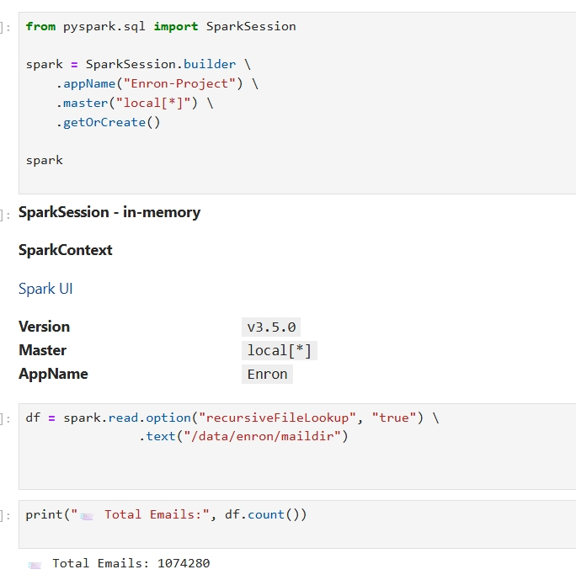

The dataset was accessed directly from the container filesystem using PySpark:
df = spark.read.option("recursiveFileLookup","true")/
.text("/data/enron/maildir")

This command recursively loads all email files into a Spark DataFrame.

Dataset Size Verification
The total number of text records imported:
Total Emails: 1,074,280
This confirms that over one million email messages were successfully loaded into Spark for analysis.
3. Data Cleaning

The emails are unstructured text files with inconsistent formatting and unnecessary blank lines.
To prepare the dataset:

Cleaning Actions:
Split each email into individual words:
explode(split(col("value"), " "))

Remove blank or null tokens:
filter((col("word") != "") & col("word").isNotNull())

This ensured:
Empty tokens were removed.
Only valid words were used for analytics.

4. Data Analysis
Objective
The main analytical goal was to identify the most frequently occurring words across the entire Enron dataset to uncover communication patterns and commonly used structures within business emails.

Word Frequency Processing

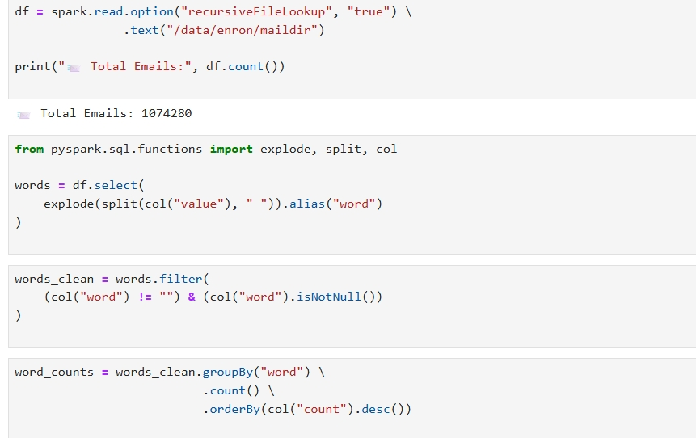

Words were grouped and counted across all messages:
word_counts = words_clean.groupBy("word")\
\ .count()
.orderBy(col("count").desc())

Top 20 Results :
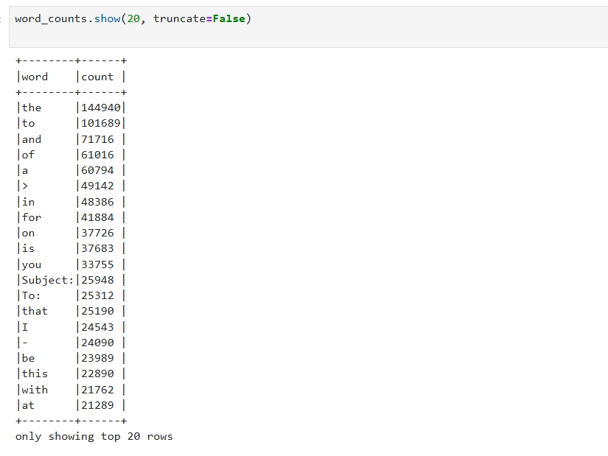
Observations
1- Common English stop words dominate
Words such as the, to, and, of are expected in natural language text datasets.
2-Email metadata is prevalent
Email metadata is prevalent
Subject:
To:
From:
Date:
Mime-Version
Content-Type
appear frequently because headers repeat for each email, significantly influencing word distribution.

Unstructured textual noise

Symbols such as > and - demonstrate how raw text includes email formatting characters that typically require further cleaning to improve semantic analysis.

5. Challenges and Solutions

Challenge :
Docker container permission errors during output directory creation
Solution:
Switched to root user and applied permissions using chmod -R 777 /data.

Challenge :
Spark failed to locate the HDFS endpoint
Solution :
Reconfigured Spark using the Hadoop default file system address (hdfs://hadoop-namenode-1:9000).

Challenge :
Handling over one million text records

Solution :
Utilized Spark's in-memory distributed processing to efficiently batch-process the dataset.

Challenge :
Text noise and inconsistent formatting

Solution :
Filtered null and empty tokens to normalize word extraction.

Conclusion :

This project successfully demonstrated the complete big data pipeline using Hadoop and Spark:

Distributed data ingestion into HDFS.
Processing over 1 million email records using PySpark.
Cleaning and transforming unstructured textual data.
Performing a scalable Word Count analysis.
Exporting results in CSV format for review.
The analysis showed that email datasets contain heavy metadata repetition and common stopwords, highlighting the importance of advanced preprocessing for deeper insights

Appendix – Key Code Sample

Spark Session Initialization
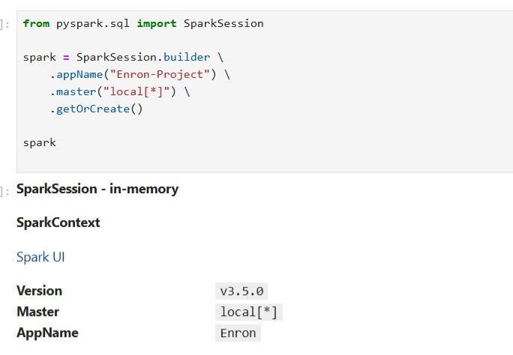

Data Load
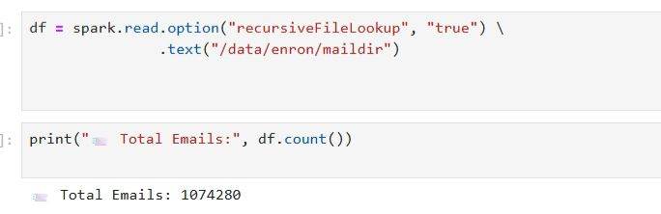

Word Processing
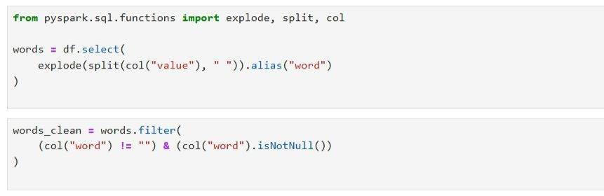

Word Count
